1. Provide a screenshot to show that you successfully created the two folders: input and output.

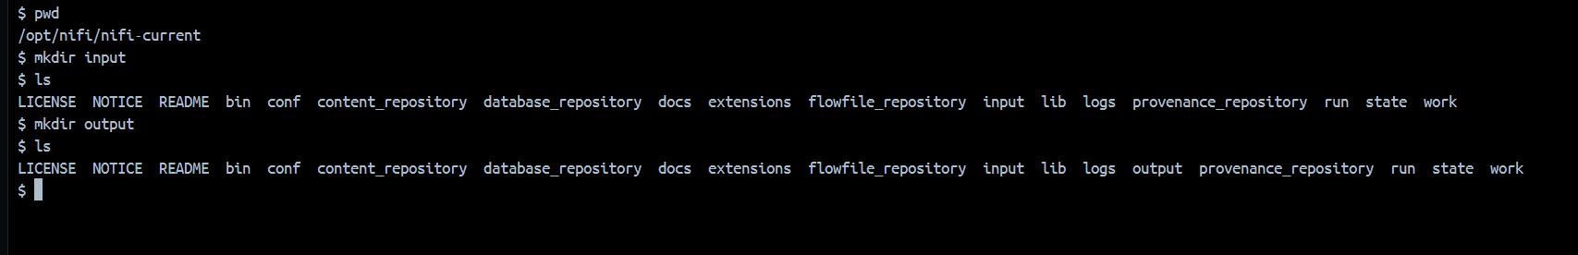

1. Provide a screenshot to show that you successfully copied the Activity17_1.xlsx Excel file to the NiFi *server*.



1. Provide a screenshot to show that you are able to successfully open NiFi from the browser.

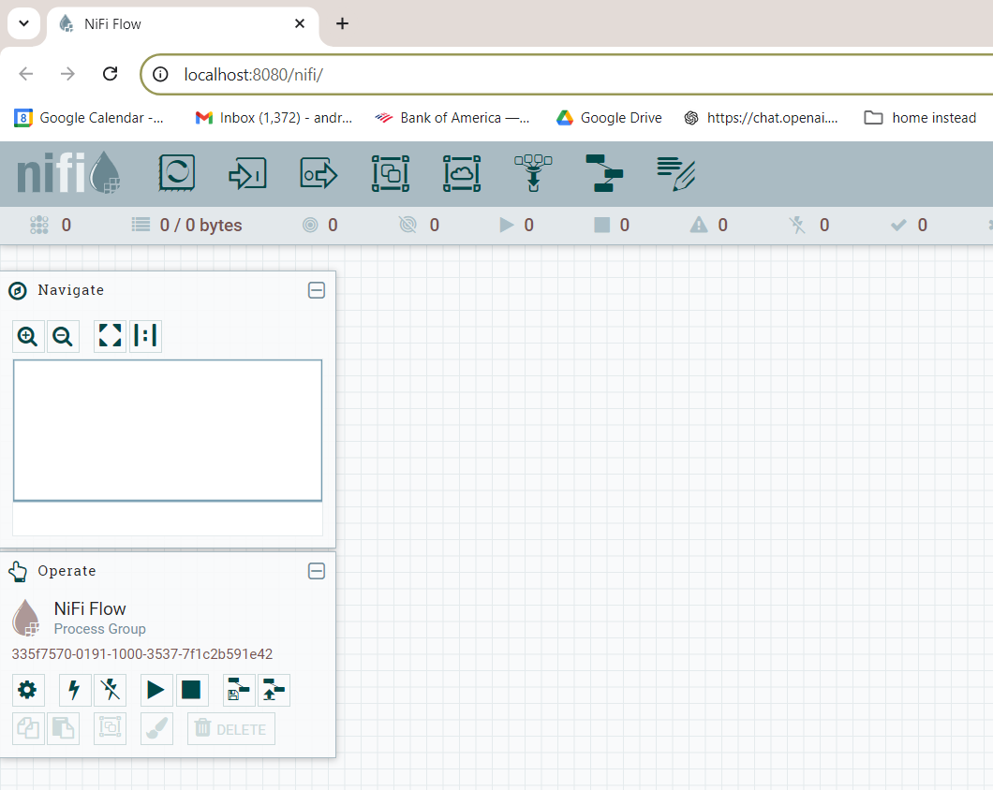

1. Provide a screenshot to show that you successfully created the new Activity17.1 process group.

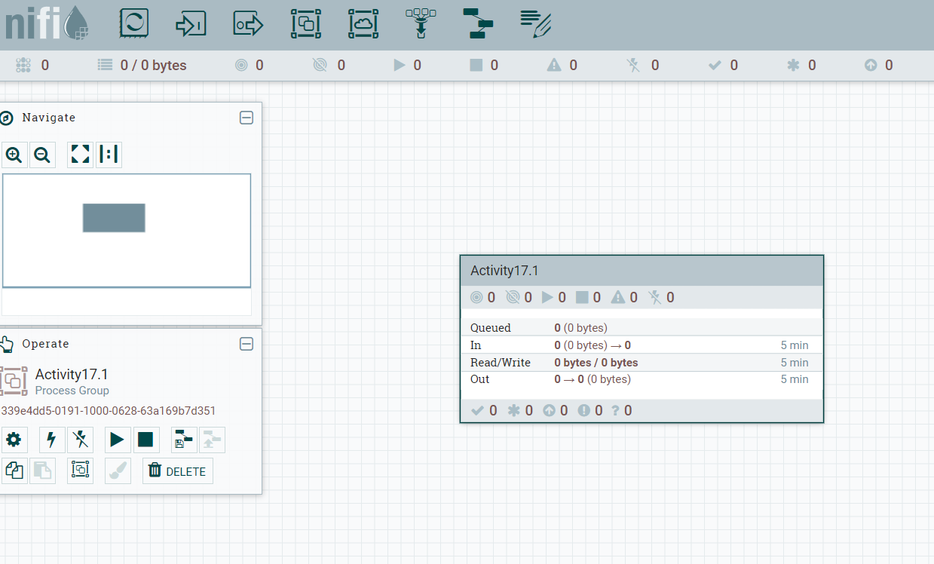

1. Provide a screenshot to show that you successfully added the ConvertExcelToCSVProcessor *processor* to the NiFi canvas.

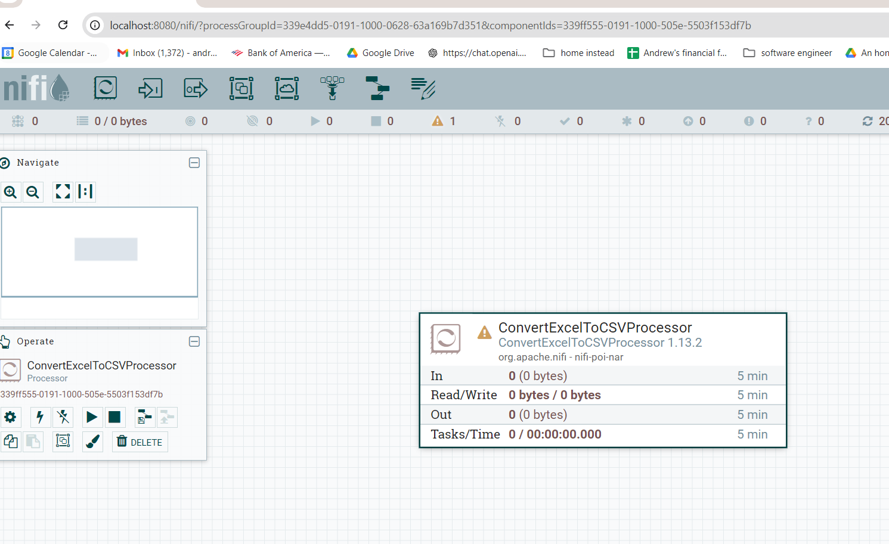

1. Provide a screenshot to show that you configured the *properties* for the ConvertExcelToCSVProcessor *processor* correctly.

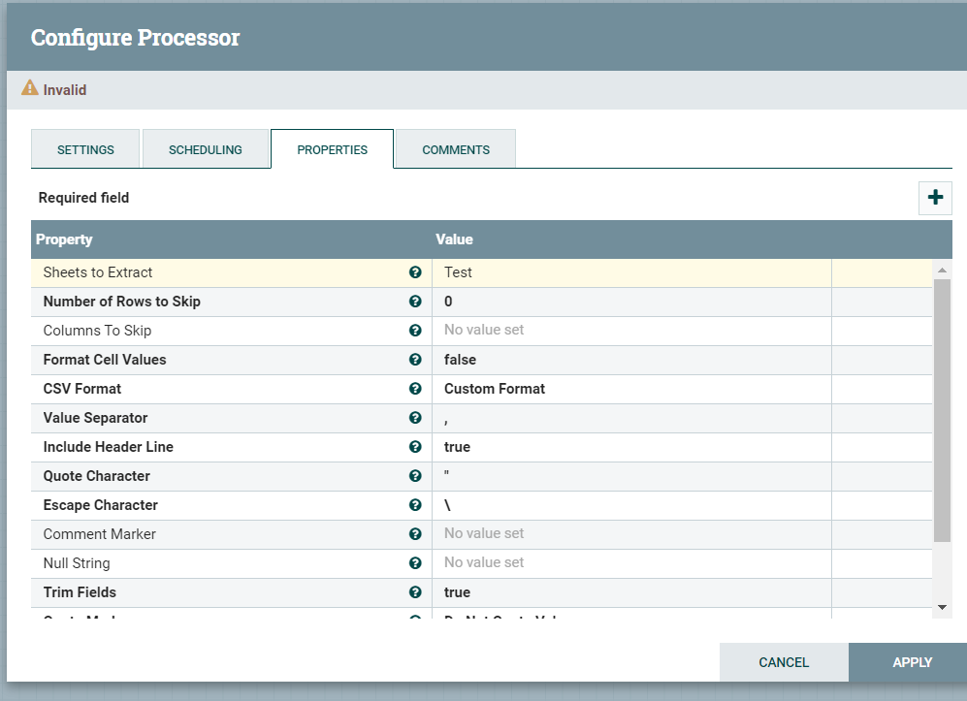

1. Provide a screenshot to show that you successfully added the GetFile *processor* to the NiFi canvas.

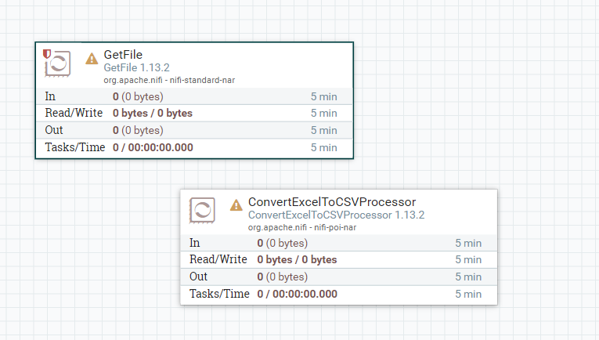

1. Provide two screenshots. The first screenshot should show that you set the values in the PROPERTIES tab correctly. The second screenshot should show that you updated the scheduling time in the SCHEDULING tab correctly.

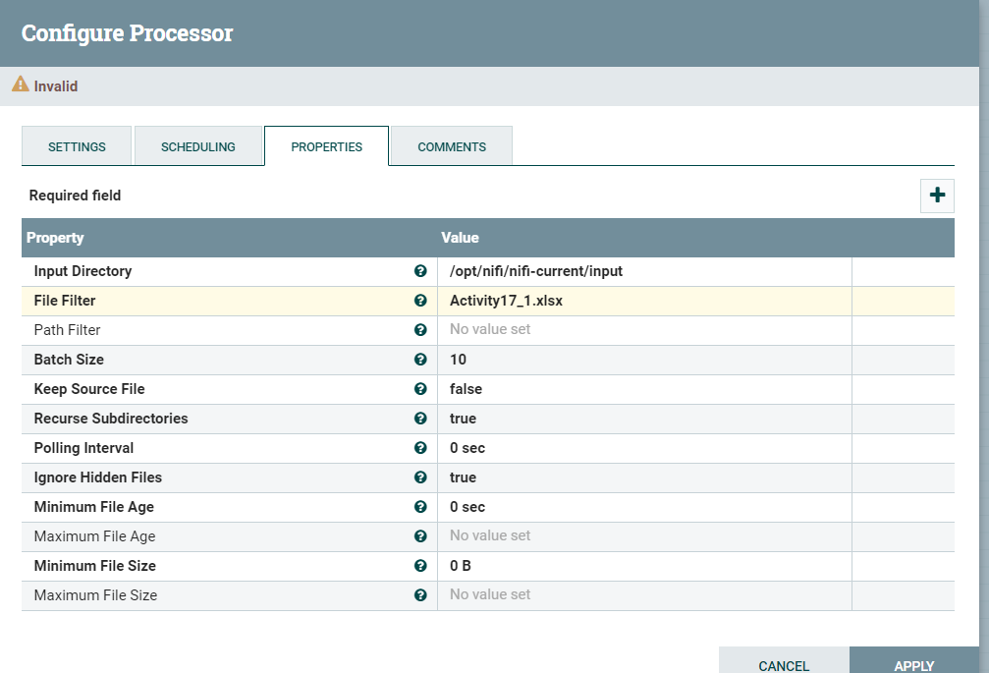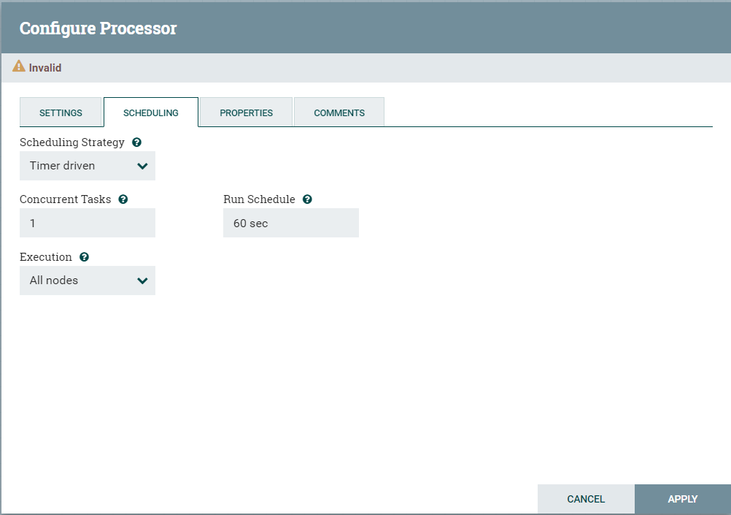

1. Provide a screenshot to show that you successfully added the PutFile *processo*r to the NiFi canvas.

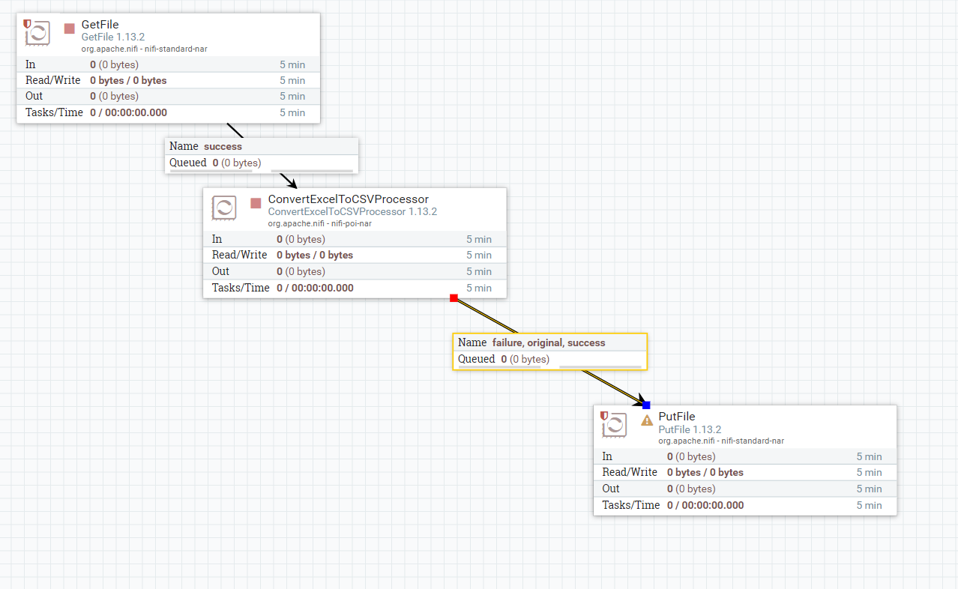

1. Provide two screenshots. The first screenshot should show that you set the values in the PROPERTIES tab correctly. The second screenshot should show that you updated the scheduling time in the SETTINGS tab correctly.

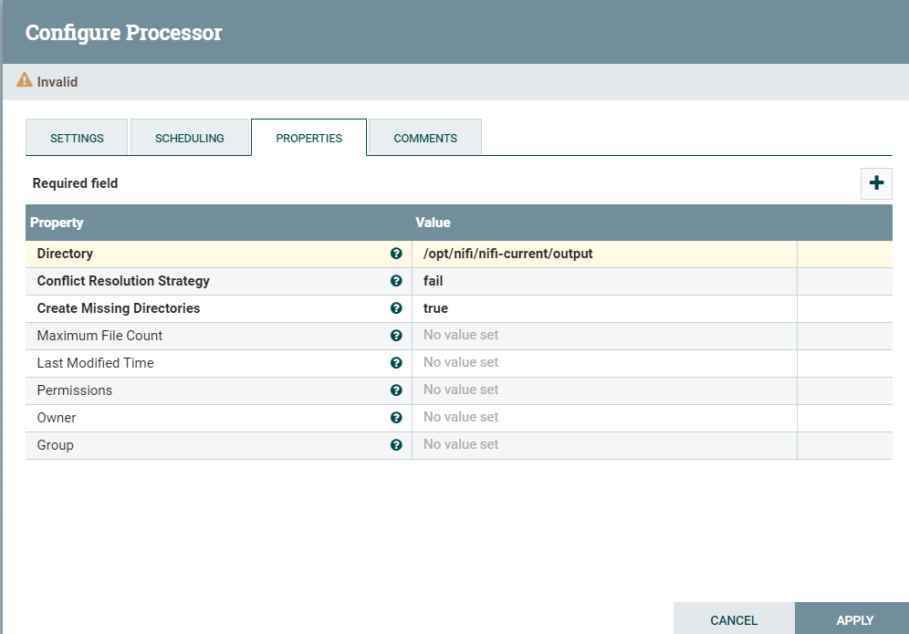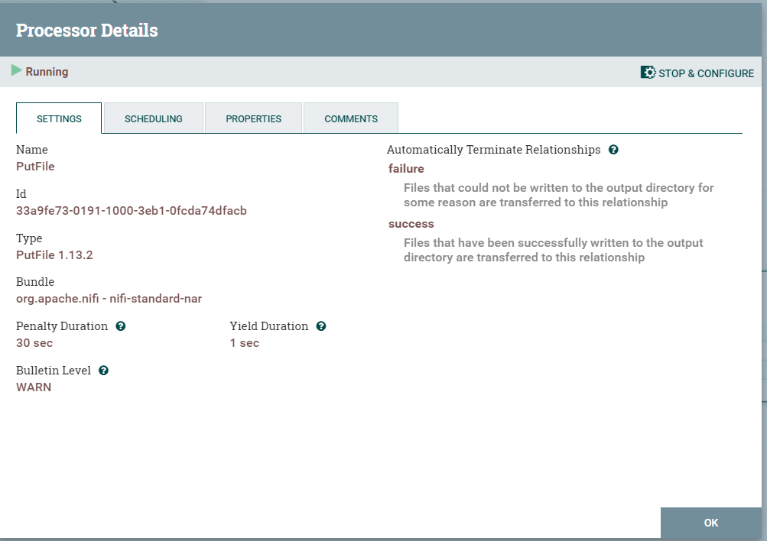

1. Provide a screenshot to show that you successfully connected the GetFile and ConvertExcelToCSVProcessor *processors*.

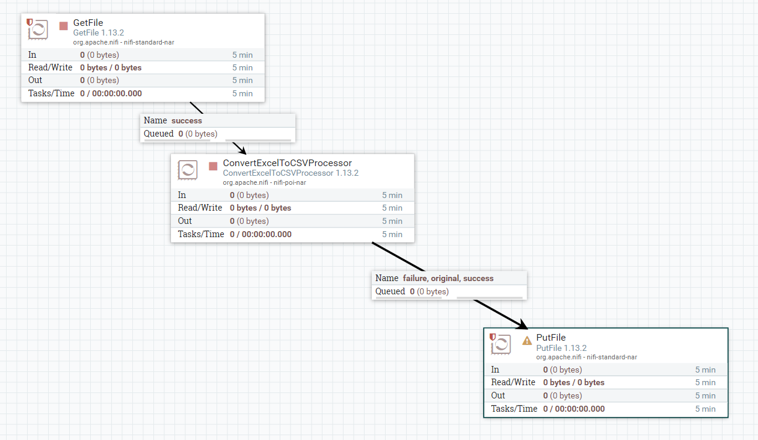

1. Provide a screenshot to show that you successfully connected the ConvertExcelToCSVProcessor and PutFile *processors*.



1. Provide two screenshots. The first screenshot should show that the GetFile *processor* is running (as indicated by a green arrow). The second screenshot should show that the input folder is empty (i.e., that the GetFile *processor* has picked up the file from the input folder for processing).

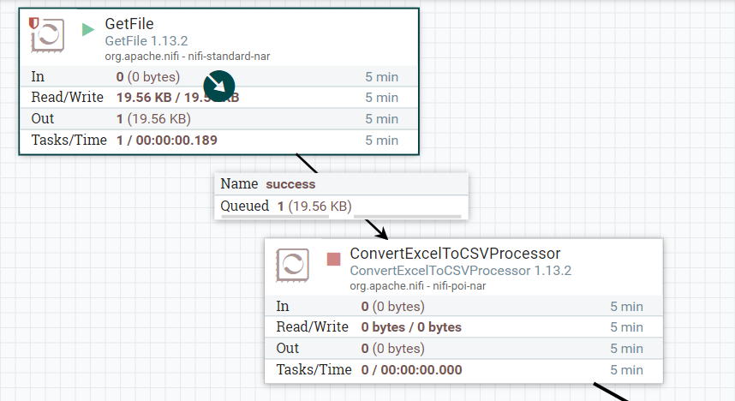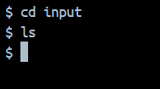

1. Provide a screenshot to show that the ConvertExcelToCSVProcessor *processor* is running (as indicated by a green arrow).

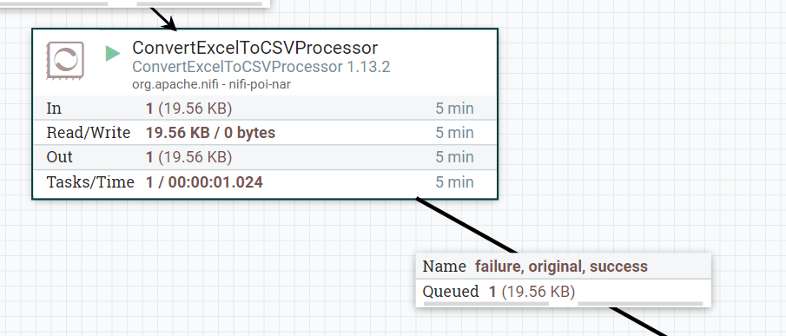

1. Provide a screenshot to show that the PutFile *processor* is running (as indicated by a green arrow).

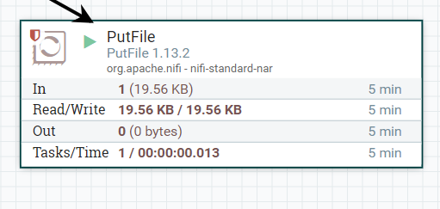

1. Provide a screenshot to show that the CSV file has been created.

